Haptics and You (What about Bobs) – Unit 8

Corey Crooks
Purdue University Global
IT302—Human Computer Interaction
Theodore Witt
October 18, 2022

Haptics use a number of different mechanisms in order to provide different touch-driven sensations to a user in an environment that may not be capable of such an experience otherwise. For example, haptics can be used in a cell phone like the Samsung Galaxy Note 8 via a series of small vibrations to fool the users into feeling the press of a button that does not exist. It can also be used more intensely in HaptX gloves that utilize air compressors, strings, tension motors, and tensile air pockets in the gloves’ fingertips to provide sensations such as resistance and touch to users in a virtual environment that has no physical objects. Typically, haptic devices are sorted into different categories as defined by their interaction with the user. Graspable devices have the user engaging with them via a physical grasp that the user must maintain in order to receive the intended haptic effect similarly to the Valve Knuckles VR controllers. Touchable devices typically only engage with the user when they touch said device such as for braille readouts. Wearable devices must be worn by the user in order to feel the haptic suite the device has to offer such as shock vests for physical therapy and Parkinson’s treatment.
Samsung Galaxy Note 8 (Touchable):
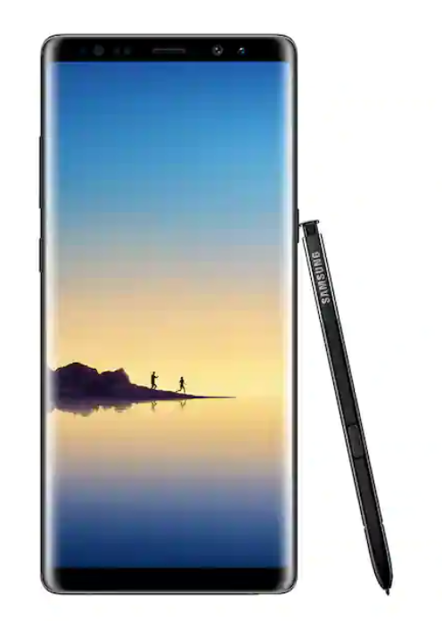
In the Samsung Galaxy Note 8, haptics are used in a myriad of different ways to improve and revolutionize the user experience. Some of which are small changes, and some are significantly more drastic. Overall, the haptics in this device would fall under the category of “touchable”, since you would interact with this device and the haptics therewithin via touch. One functionality of the more drastic haptic sensors in the Samsung Galaxy Note 8 would be the inclusion of vibration modes. In this, you may set a specific way for your phone to vibrate at certain parts to serve for notifications, communication, or any other means. This is typically measured in milliseconds. For example, a vibration code of 255, 15, 255, 14, 30 would mean the phone will vibrate for 255 milliseconds, pause for 15 milliseconds, vibrate again for 255 milliseconds, and pause for 14, and then vibrate for 30 milliseconds (The Tree Team, 2022). With Third-party applications, however, you may get more in-depth with customization for adding features like vibration strength. These features could be found in something like LightFlow for android. Features like this give the phone its edge in productivity. Knowing exactly what notification arrived on your Galaxy Note 8 is paramount to prioritizing during a busy day, and can completely revolutionize how you use your mobile device. Some notifications may not have a priority as high as others, and knowing which is a text from a friend apart from an email from your boss can be extremely important.
Users overall seem receptive to the haptics found within the Galaxy Note 8. A review from Chris Chavez mentions all sorts of features from haptic feedback integration into the built-in S pen, to a haptic motor found near the bottom of the screen to mimic a “home” button. In his review, Chavez described the Samsung Galaxy Note 8 as having “easily some of the best haptic feedback you’ll find this side of the iPhone”.
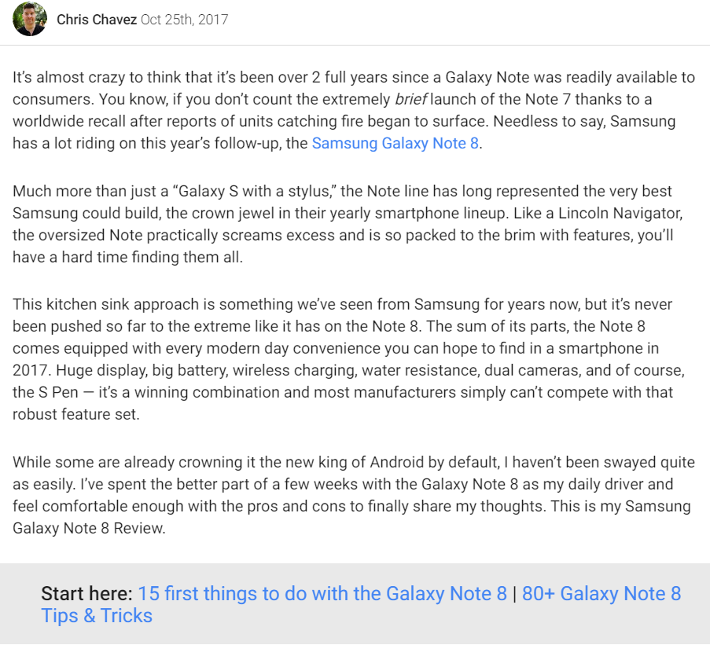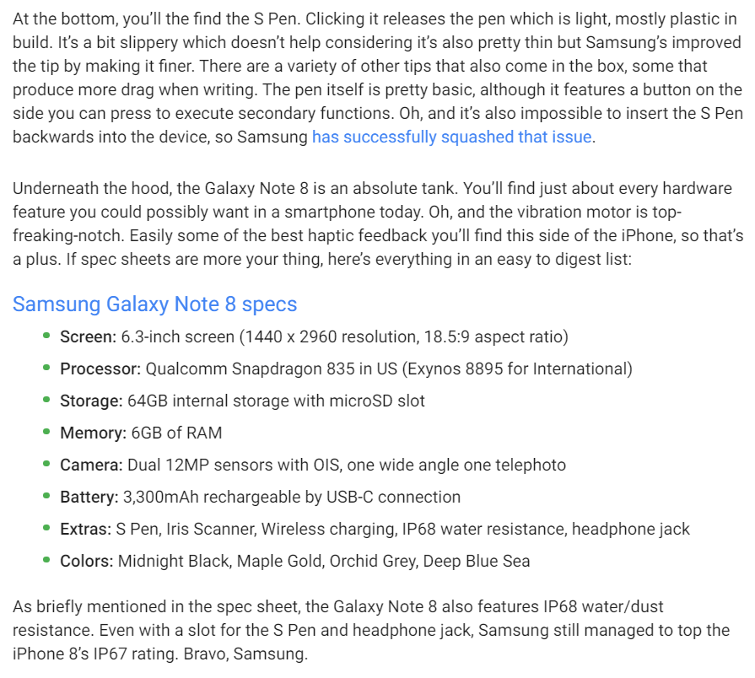
The haptics mentioned in this paper are not without drawbacks, however. Firstly, battery is seriously something to consider. It takes energy to power the motors found within the Samsung Galaxy Note 8, and having long strings of vibration codes may run your battery down faster than expected. If a working phone is essential for the entirety of a user’s line of work, then that user may think about arranging their device to produce something more simple in order to maintain the battery throughout their day. Secondly, overuse of haptic feedback is simply obnoxious. If a user has this device sitting on their desk during a meeting, and their vibrations are constantly going off, it could have a negative effect on the meeting itself. Constant buzzing could throw off any semblance of pacing through your workplace, and make you a target for new workplace protocols.
HaptX VR Gloves (Wearable):
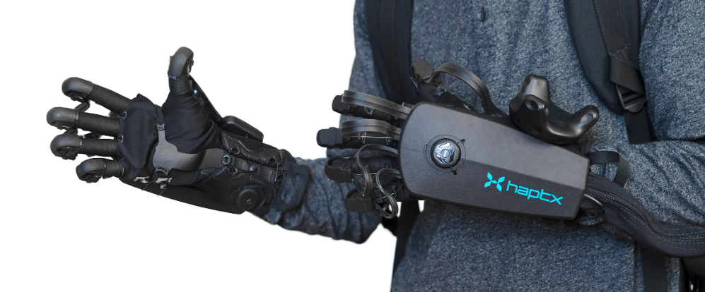
HaptX VR Gloves are on the cutting edge of technology. Currently, they are undergoing rapid development, and engaging in innovation like never before seen. Given that the VR market itself is still in infancy, these gloves will only grow more and more profound as time goes on (HaptX Inc., 2022). These gloves, as could be deduced, go under the haptic category as wearable, as they physically fit on the hands of the user for use. Currently, these gloves are used in beta programs developed specifically with them in mind, so experiences are relatively limited at its current phase. Debuted earlier, the HaptX gloves were seen driving mechanical arms to mimic a user’s motions. Implications of such a device could go a long way in things like construction where a single person does not have the capability to lift the materials required for putting together Skyscrapers. A mechanical suit using this technology could be built for a user to pilot similar to what is seen in Aliens. Moreover, the technology behind the gloves are some of the driving features for the existence of this technology. Seen on the backs of the gloves are large motors, trackers, and a battery for various functions. Motors give tension to strings that are wired to each finger. These strings restrict the movement of the user’s fingers after receiving signals from a virtual environment. This combined with small airbags on the tips of fingers can give the sensation of touch for objects that are not physically present. This haptic technology has the potential to revolutionize this industry. Transporting a user to a new environment has been the driving purpose of VR technology, and haptics integrated in such an intricate level can provide a feeling of immersion like never before.
These, again, do come at a cost. Firstly, there’s a physical cost. The weight of these devices is extraordinary. Adding a number of gadgets to your arms on top of gloves and batteries can seriously weigh a user down. If they have a disability targeting arm strength, or are a younger user, then this could seriously impact their ability to engage with this device. Secondly, these devices are currently extremely limited. A user needs to request a quote for the device, and the company making them must approve the request to start a business query. If a user is lucky enough to be sent a development kit, they can expect the cost to be at minimum tens of thousands of U.S. dollars (Lang, 2021).
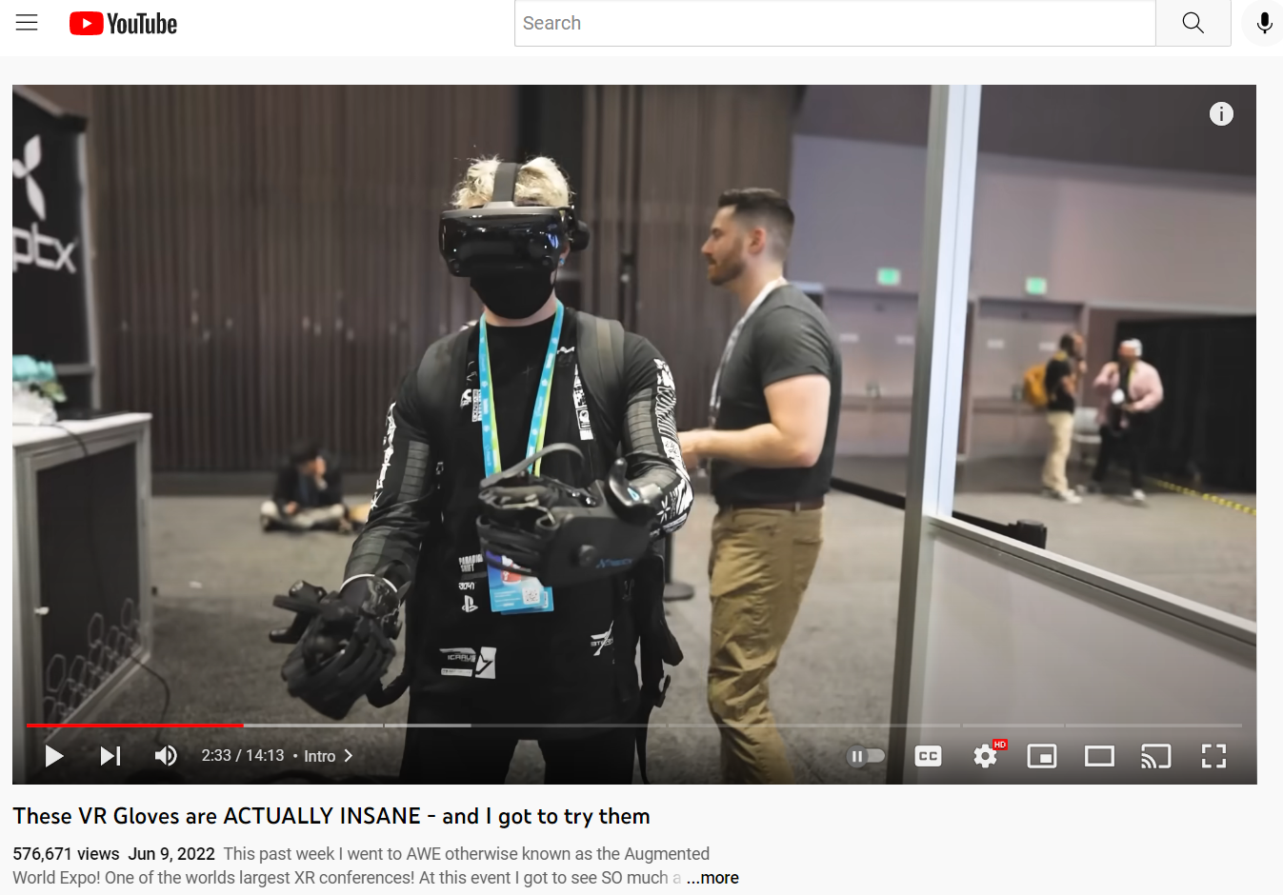
Since unfortunately these are strictly enterprise gloves, the reviews are rather scarce. Fortunately, there is a VR youtuber by the channel name ThrillSeeker that was able to try them back in May of 2022. Simply put, he says “I felt things that weren’t there.” And calls the HaptX gloves “the best haptics solution in the industry” (ThrillSeeker, 2022).

References
HaptX Inc. (2022). HaptX Home. Retrieved from haptx.com: https://haptx.com/
Lang, B. (2021, January 28). HaptX Launches New & Improved DK2 Haptic VR Gloves for Enterprise. Retrieved from RoadToVR: https://www.roadtovr.com/haptx-dk2-vr-glove-launch/
The Tree Team. (2022, January 5). Google Play Store. Retrieved from play.google.com: https://play.google.com/store/apps/details?id=com.phongphan.vibrate&hl=en_US&gl=US
ThrillSeeker. (2022, June 9). These VR Gloves are ACTUALLY INSANE - and I got to try them. Retrieved from Youtube: https://www.youtube.com/watch?v=DkBUoAXagL8&t=186s

